World of Senses Workshops

- Our senses:
- sight
- hearing
- smell
- touch = surface sensation
- taste
- vestibular system = balance
- proprioception = body awareness
- pain receptors
- thermo receptors
- Synaesthesia - what is the taste of the texture of the high C sound?

- Sensitivity

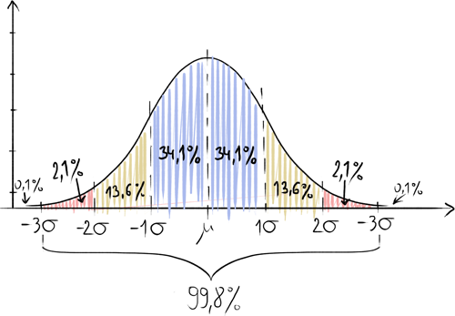

Hypersensitivities are usually easy to spot
Pay attention to avoiding or being triggered by:
- certain situations
- certain sounds
- certain textures (including: belts, elastic bands, tags)
- certain behaviors and people
- certain smells
- certain places

Remember, sometimes hypersensitivity can also manifest as a fascination with certain phenomena, to the point of looking for them and "turning off" in their presence

Hyposensitivities
Look for signs of seeking stimulation or not feeling stimulus.
ATTENTION! Being hyposensitive does not make us superheroes! Just because something doesn't hurt doesn't mean it doesn't cause damage.

5. On a scale from -5 to 5, with 0 being “average,” how would you rate the sensitivity of your sense of:
- sight _____________
- hearing _____________
- smell _____________
- touch = surface sensation _____________
- taste _____________
- vestibular system = balance _____________
- proprioception = body awareness _____________
- pain receptors _____________
- thermo receptors _____________

6a. What sensory stimuli worry/annoy/disturb you the most?

6b. What sensory stimuli make you happy/stimulate you/calm you down/give you the most pleasure?

