How balancing senses can improve quality of life in Autism

I N T R O D U C T I O N  Role of Sensory systems  We explore or learn about the world around us through sensory experiences. Our body get sensory inputs from sensory systems as  Visual (we see)  Auditory (we hear)  Oral/Gustatory (we taste/smell)  Tactile (we touch)  Proprioceptive (we use muscle and joints)  Vestibular (we move against gravity)  To learn and respond appropriately in different situations, an individual depends on these functions |  | How our brain uses all senses ?  Through a neurological process called –  Sensory Integration:  Sensory Integrations is ability to  - Take in information from all our senses  - Choose which information to pay attention to  - Make sense of information  Choose an appropriate response

Sensory integrations process simplified

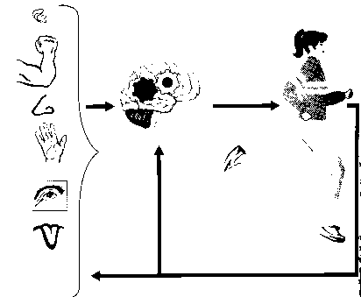

Sensory Integrations Dysfunction (SID)  Person with ASD may present with SID and may have difficulty  - Choosing what information to pay attention to and what to ignore  - Organising the information so that it makes sense  - Making an appropriate response  - Person may get overloaded (frustrated), demanding, angry and busy in an attempt to have some control  Parents, teachers and others may misinterpret these behaviours as “BAD” |  | What can be done ?  Sensory integration therapy  - Sensory integration therapy attempt to alter central nervous system organisation in a way that improves individual’s response to sensory stimuli  - These are series of specific, controlled sensory and motor experiences (sensory diet)  - Structured sensory integrations activities are used to develop new organisation in brain  - Child experiences a sense of control over their bodies and environment  - Learns to better process the sensory input  Note: Sensory integration therapy uses planned, controlled sensory input (somatosensory, vestibular, proprioceptive etc.) in accordance with the child’s neurological needs designed specifically after detailed sensory assessment by a qualified Occupational Therapist

