

July 26-29, 2005
Information Pack

Introduction
With just under three weeks to go until Autscape, we hope you are getting excited about the experience. This is the somewhat delayed information pack. We understand how important it is, especially for autistic people, to know what to expect before doing something new. Unfortunately, we don't always have all the information ourselves. In this document we will give you as information as we can. The website will contain updates as they become available and some, such as the programme and a floor plan, will be given out at registration.
This is for your information and you may do with it as you will. Print it, transfer to a PDA or laptop, or just read it. If you’re printing and want to conserve ink, you may want to skip pages 5& 6 as they contain a lot of pictures. We strongly suggest that you print the whole Travel section on pages 2-4 if you are driving and at least page 4 Contact Information and Travel Notes no matter how you are travelling. Most of the information on pages 2-13 is also available on the website: http://www.autscape.org/. Be sure to let us know right away if you have any special needs such as a special diet.
The most important section is on pages 7-10, Autistics at Autscape. Please pay special attention to this section. If you have any questions, feel free to contact us, preferably by e-mail: autscape@paradox.freeserve.co.uk If you can’t e-mail, phone: 01606 48798.

Contents:
Introduction 1
Travel 2
Location & Directions 2
Bus Service from Bath 3
Contact Information and Travel Notes 4
Facilities 5
Accommodation 5
Buildings and Spaces 5
Food Service 6
Autistics at Autscape 7
Catering for Autistic Needs 7
Challenges 8
Expectations 10
Programme 11
Work Shift Rebates 11
Schedule 12
Timetable 13
Packing List 14

Travel

Location & Directions
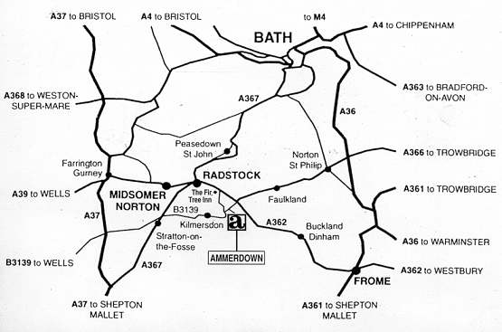
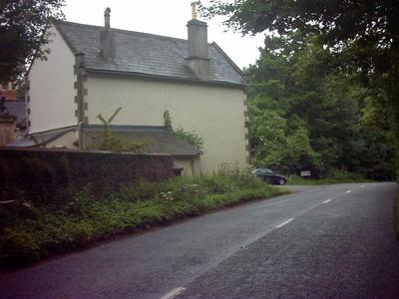
Autscape 2005 will be held at Ammerdown Centre, near Radstock, Bath. The Ammerdown Centre nestles in the beautiful Somerset countryside, and the peace and tranquillity of Ammerdown Park, three miles south of Radstock and only thirteen miles from the Georgian City of Bath. Most of the extensive grounds are available for walking in and heron, buzzards and many other birds, as well as deer, can often be seen.

By Road
Ammerdown lies in a square of land situated within the right angle of the A362 Frome to Radstock road and the B3139 road to Wells. Access is from the latter road through the park gates, flanked on either side by a gatehouse. (photos right)
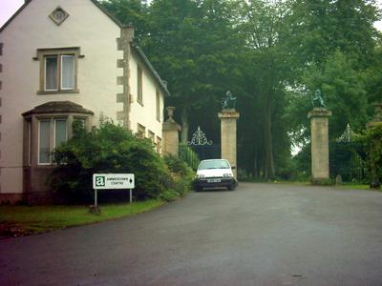
If you need more specific directions, please contact us.

By Train
The nearest main line station is Bath Spa. A frequent service of fast main line trains operates from London Paddington direct to Bath. Virgin Cross Country trains operate to Bristol Temple Meads from where there is a frequent service to Bath. Principal regional train services operate direct to Bath from Cardiff, Oxford, Brighton/Portsmouth/Southampton etc.
British public transport (especially rail) is notoriously unreliable. Even if they run late, they will usually arrive eventually and get you to your destination. Try not to become too distressed about inconsistencies or deviations from the published timetables. Make sure you leave early enough for some things to go wrong along the way. Carry contact information for yourself, an emergency person, and Autscape with you.

By Air
The nearest airport is at Bristol. From there, Bath Spa can be reached by rail or taxi.

Bus Service from Bath
We will be able to provide mini-bus transport from Bath Spa to Ammerdown Centre at a cost of £5 per person. The buses will leave from Bath Train Station at approximately 3:00pm and 4:30pm on Tuesday, 26 July. On the return journey, they should arrive back at approximately 2:00 and 3:30pm on Friday, 29 July.

Contact Information and Travel Notes
This does not need to be returned. It's just a guideline for information you might want to have in one place. Fill in the relevant information, then print it and carry it with you in case of missed or cancelled flights, missed rides, getting lost while driving to Autscape, communication difficulties with strangers, or other unexpected mishaps.

How to contact Autscape
Up to and including 25 July: | 26-29 July:
Autscape  c/o BAS  13 Boult Street  Reading  RG1 4RD  Phone: 01606 48798  Fax: 0118 947 6813 | Ammerdown Centre  Ammerdown Park  Radstock  Somerset  Phone: 01761 433709  Ask for Autscape organisers.  Mobile: 07867 59751

Personal Information
- Name
- Home Address
- Phone Number

Transport
For each flight, train or bus you’ll be taking:
- Route or flight numbers
- Origin (home town) and destination (probably Bath)
- Changes (place names)
- Departure times (and arrivals if needed)
- Car rental reservation
- Other transportation information

Stops along the way
If arriving somewhere else before Autscape or meeting others along the way:
- Name of hotel or other accommodation where you’ll be staying.
- Address and phone number where you’ll be staying.
- Names and phone numbers of everyone you’ll be meeting up with. Mobile numbers would be very handy here.
- Times and locations for ride meets.
- Alternative trains, buses, etc. in case you miss one.

Someone to phone
Contact information for someone you can call, or ask another person to call for you in case of problems:

Facilities

Accommodation
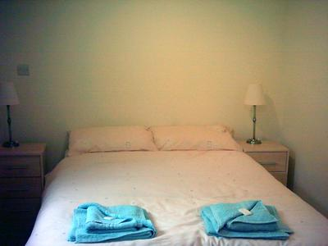
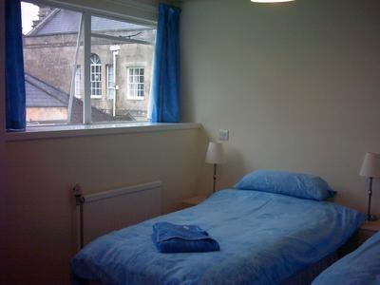
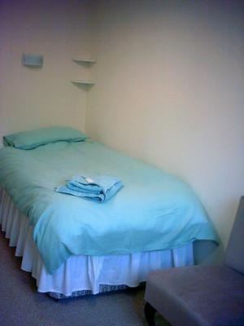
Accommodation for most people will be in twin bedded rooms with ensuite shower room. All the facilities are very recently renovated and modernised. Some people will be camping on-site. Campers can use the facilities in the Peace Cottage and the main building.

Buildings and Spaces
The venue is made up of several buildings, some attached, some detached.

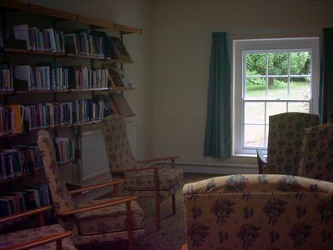
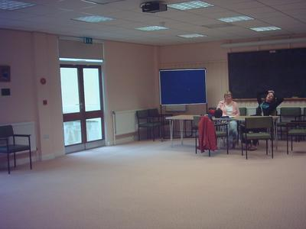
Main Building
Most bedrooms
Dining hall
Large meeting room
Crèche
Lounge (with bar in evenings)
Craft shop
Reception
Toilets
Shared bathrooms
TV room
Library

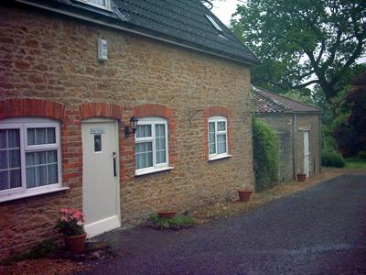
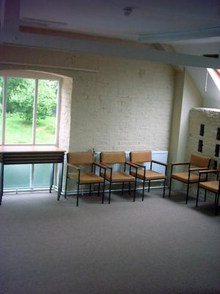
Peace Cottage (right)
Self-catering kitchen
Disabled toilet and shower – campers may use this
Most organisers’ rooms

Dovecote (left)
One bedroom
Small meeting room (upstairs)

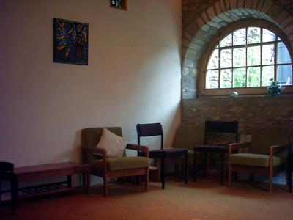
Quiet Room
The room that will be the quiet room for Autscape is formally known as the Harness Room, so named because of its former use in horse keeping. No interaction or unnecessary noise should take place in the quiet room.

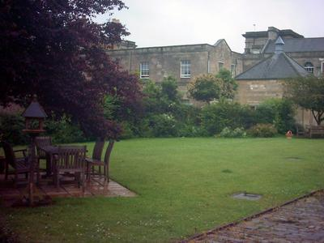
Garden
Other than early morning and leisure sessions, when Shintaido will take place there (weather permitting), the garden is available for outdoor games (some equipment available). You may take your meals to the garden if you wish. If you smoke in the garden (no smoking indoors) please use the ashtrays provided.

Chapel
Participants are welcome to join the resident community for prayer at specified times, or to use the chapel for private prayer whenever it is not in use. Meditation sessions (led by one of our participants) and an informal music group will also take place in the chapel.

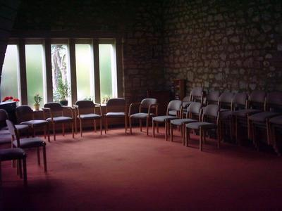
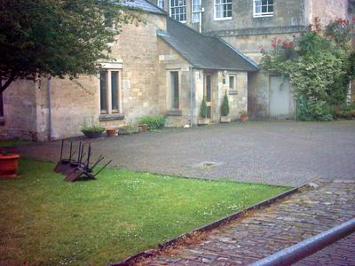

Food Service
Autscape registration includes 3 meals per day unless self-catering or staying off-site (no breakfast). Special diets can be catered for if notified in advance. Food is served in a communal dining hall, but it is possible to take your meal to the garden or your room for more privacy. Those who are self-catering may use the kitchen located in the Peace Cottage.
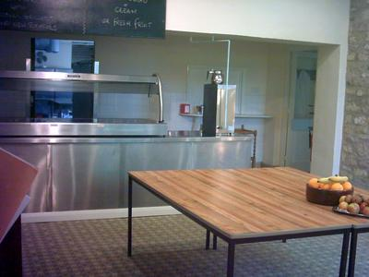
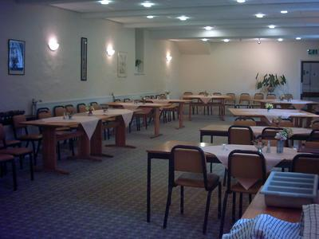
Mealtimes are: Breakfast 7.30-8.30, Lunch 12.30, Supper 6.30. If you need more food or at different times, you may use the self-catering kitchen in the Peace Cottage.

Autistics at Autscape
We will be taking autistic needs into consideration throughout the planning and running of Autscape. This section includes the things we've implemented to try to make things easier, the things we know will be challenging for some, and what we need from you in order to make sure it all goes well for everyone. Of course there's no way we could anticipate, let alone accommodate, every need of every autistic person. Some autistics' needs aren't even compatible! We are doing our best within the constraints of our knowledge, energy and resources. It is important to remember that nearly everyone at Autscape, including presenters and organisers, is also autistic. They may be struggling to cope just as much as you.

Catering for Autistic Needs

Social Interaction
A lot of people are, understandably, quite concerned about the heavy social demands of being in a large group for several days. There is no requirement to socialise at all, and there will be no implicit or explicit disapproval of those who choose not to interact with others. Everyone will be provided with coloured badges they can use to indicate whether they would like to socialise or not.
Red: Please do not approach me. I do not wish to socialise with anyone.
Yellow: Please do not approach unless I have already told you that you may approach me while I am wearing a yellow badge.
Green: I would like to socialise, but I have difficulty initiating. Please feel free to approach me.

Additionally, those who would not like to be in videos or photographs will be wearing a black circle. Please respect all these badges for the safety and comfort of all participants.

Sensory Issues
Sensory issues, and mechanisms to reduce them, will be common and totally acceptable. No one will think it odd or cause you any difficulty for wearing sunglasses, earplugs, headphones, or whatever you may require. Unfortunately, during renovations to the venue, fluorescent lights were added to some of the meeting rooms. If this is a serious problem for you, please let us know so we can arrange alternative lighting. We are hoping that natural light will suffice in at least one of the rooms.

Autistic Behaviour
Stimming (repetitive movements), echolalia, distractibility, different or impaired conversation skills, atypical body language, and perseveration (obsessiveness), to name but a few possibilities, are expected and accepted as part of an autistic conference. Appearing (or, indeed, being) completely NT (neurologically typical / ‘normal’) is also perfectly acceptable.

Food Service
Special diets can be catered for if we are told in advance. Meals are served cafeteria-style, with a queue and servers, in a communal dining hall. That part is not very autistic friendly, but once you have your meal you may take it to your room or out to the garden if you find a full room difficult. No food or drink may be taken to the meeting rooms due to problems with spills.

Getting Away
There will be a designated quiet room where you can go to relax and 'chill out' if things are getting too much. There are also extensive grounds you can walk around in. The town of Radstock is a long walk or short drive from the centre (about 3 miles) and the City of Bath is 30 minutes by car.

Challenges
Any group gathering of this size will be difficult for most autistic people. Although we have done our best to cater to autistic needs, it is impossible to make it perfect in every way for every (or any) participant. There remain some things many people may find challenging, but if you are prepared, there are things you can do to make it easier for yourself.

Choices
The difficulty: There are many choices to be made before and throughout the conference. From what your preferences are in a roommate, to what you'd like to eat, to which workshops or free time activities you'd like to participate in. Choices are difficult for many people, and autistic people often find it extra difficult.
What we will do: We will try to make it easier on you by giving as much information as possible in advance so you can consider your options.
What you can do: When the information is available to you, try to consider your options well ahead of time. Menus may be provided before Autscape, but if that is not possible, they should be posted near the dining room. You can make your food choices, or at least have something in mind, before entering the serving queue. Information about workshops and how they are scheduled should also be available beforehand. If you decide what you would like to go to, and what interests you for free time activities, this can limit the stress of having many choices to make when you have a lot of other things to cope with. It has the additional benefit of helping us prepare for how many people will be at each activity.

Sharing a Room
The difficulty: Many participants will be sharing a room with someone they don't know. We understand this can be very difficult, but it is the only way to allow as many people as possible to participate in Autscape. Where interaction and noise level choices are not the same, the more restrictive level must be adhered to.
What we will do: We will try to match you up with the most compatible roommate we can find.
What you can do: If noises disturb you, earplugs may help you sleep more comfortably. If you are up a lot in the night, please be quiet and respectful of your sleeping roommate. You can choose to have a 'no interaction' room, and please respect it if your roommate would prefer not to interact in the room.

Busy Days
The difficulty: Some people will find the amount of active time each day quite tiring.
What we will do: We have scheduled long (at least 30 mins) breaks between each activity, and a leisure session each afternoon. Late afternoons and evenings are more relaxed, with free time and discussion groups.
What you can do: Remember to take time out to relax in whatever way works best for you. It is also more difficult to cope with being busy if you're tired, so adequate rest and sleep will help you cope with as much activity as you would like. You always have the choice not to do a particular activity, or to leave early if you're feeling stressed. Only you can decide what you would like to do with your time at Autscape. See also: Choices.

Unstructured Time
The difficulty: Some autistic people don't know what to do with themselves if there is a large amount of unstructured time, especially in an unfamiliar place. Knowing what to expect and what to do all the time can help some people to cope better.
What we will do: We have tried to keep a balance between structured and unstructured time. We have kept large blocks of totally unstructured time to a minimum, and even that has many options for activities you could do alone or with others to fill it. Some of the options won't be determined until the event, but there will be opportunities to suggest or sign up for structured or semi-structured activities for most of the time there.
What you can do: If unstructured time is a problem for you, try to think ahead about how you would like to occupy yourself during the 1.5 hrs before supper and in the evenings. Bring your own entertainment such as books, music, electronic devices, games to share, musical instruments, or other interests and hobbies. Consider running a structured discussion one evening, and think of some topics you would like to discuss with others.

Self-Care
The Difficulty: Many autistic people have trouble taking care of themselves in various ways such as nutrition, health, and hygiene. You will have to be able to get yourself up, washed and dressed without intervention from others.
What we will do: The structure of the days will help many people with routines of rising and going to bed and taking breaks. Meals are cooked for you and served at specific times, so your nutrition should be adequately catered for as long as you partake.
What you can do: If you take any medication, you can get a day-by-day box which you can fill ahead of time. Come to meals on time and ready to eat. Take your meal away somewhere quieter if you find it hard to eat with distractions. Bring an alarm clock if you have difficulty getting up in the morning. If you have a portable alarm (such as on a wristwatch), you can set it to go off at bedtime or other important times of day. When planning how much time you will need in the morning, leave extra for dealing with an unfamiliar environment and having to share space with your roommate. Be prepared to communicate your meal choices by word or gesture before you get to the front of the queue.

Orientation
The difficulty: Knowing where to be and when to be there. Just 'following the crowd' may be a problem. Remembering where things are or what time things are happening can be difficult.
What we will do: We will provide you with a schedule, including where each event will take place, and a map of the venue. On the first evening, each participant will have an opportunity to have a tour of the facilities. The name of the rooms, their functions, and a schedule of their use, will be posted on the door of each room. The first session of the first two days will be a plenary lecture, so everyone who wishes to attend will be going to the same place at the same time.
What you can do: Wander around the facilities as much as you need to in order to find each place you will need. Head to activities with plenty of time for getting lost and found again. Locate essential facilities such as toilets, fire escapes, and the dining hall. Keep your schedule and map with you. Be prepared to ask for help or direction, with gestures if necessary. (e.g. You could point to the name of the activity you're trying to find, and if the person you're asking knows where it is, they'll probably tell you how to get there.) Rehearse some essential scripts you may need if you have difficulty asking for help.

Expectations
By coming to Autscape, we expect that you can manage certain things, or will bring someone to help you. Some of these things are listed above as “Challenges”; these are summarised below, along with some others:
- Respect others' space and property
- Follow 'house rules' about things like smoking and drinking
- Make your own choices
- Share a room (if applicable)
- Organise your time
- Take care of your health and hygiene
- Orient yourself
- Ask for help
It may sometimes be possible to arrange with another participant to help in small ways. e.g. Your roommate may be willing to wake you in the morning. However, this kind of help must be voluntary and must not be an unfair burden on others nor absolutely necessary for your coping. Due to the limits of their own needs and abilities, others may not be available or 100% reliable, even if they wish to help. If you require extensive or essential assistance, please bring a carer who can provide that for you.

Programme
Everything at Autscape is completely optional. You are not obliged to attend anything, speak to anyone (unless you are a parents), or participate in any way. If you are interested in doing things, there is plenty going on to entertain you throughout the day.
There will be formal workshops and lectures during the day on topics of relevance and interest to autistic people, broken up by meals and breaks. After lunch, we will have a structured leisure session for those who wish to participate and an outdoor pool will be available for a specified time. Before supper, you can choose from a variety of free time activities. In the evening, there will be structured and unstructured discussions and the bar will be open in the lounge.
This schedule is provided to give potential participants an idea of the flow of the days' activities, breaks, meals, and free time. The venue has asked that participants please arrive promptly for meals as the catering staff have to start clearing up and preparing for the next meal as soon as everyone is served.
The days at Autscape contain scheduled presentations in both lecture style and interactive workshops interspersed with unprogrammed time which includes leisure activities as well as meals and breaks.
The full programme is likely not to be available until you arrive at Autscape. There is some information on the website, which is repeated below, about the current timetable.

The Future of Autscape
Autscape 2005 will be an event in its own right, but we are also concerned about its future. At Autscape, we expect to create an organisation which will be the foundation of the future of Autscape and perhaps other activities. If you want to be involved in the future direction of this exciting new European event, make sure to join in the AGM on the final day.

Work Shift Rebates
We will be offering £10 ‘Work Shift Rebate’ for those who do certain jobs to help Autscape run smoothly. Most jobs will take 2-4 hours. The rebate will be given in cash on-site when the task is completed. All campers automatically receive their rebate and those coming as carers are not eligible because it is assumed they will be too busy with their caring duties. Some examples of jobs that may qualify include:
- Helping with registration and giving tours of the facilities.
- Transport to/from the venue for those who can’t use the transport we’ve arranged.
- Running leisure activities
- Running structured discussions
- Helping campers get set up
- Ushering people from train station to minibus pickup point
- Operating video camera
- Time keeping for workshops
There will be an opportunity to sign up for jobs on the first day. If you would be interested in helping with arrival (minibus, registration, tours, setting up camp) or if you think of a structured discussion you would like to run, please let us know ASAP by e-mail.

Schedule

Tuesday, 26 July
3:00 & 4:30 Minibus pickups from Bath.
4:00-5:30 Registration and Tours
5:30 Orientation Session
6:30 Supper
8:00-10:00 Structured Discussions: Sexuality (Heta Pukki), Asexuality (Jim Sinclair)
Bar open, informal discussions, free time activities

Wednesday, 27 July
6:30 Shintaido
7:30 Breakfast
9:00 Plenary Lecture: Being Autistic Together (Jim Sinclair)
10:30 Break
11:00 Morning Workshops: Who Owns the Terminology? (Larry Arnold) and Reactive Colours (Dinah Murray et al)
12:30 Lunch
1:30 Break (get ready for leisure session)
2:00 Leisure Session: Shintaido (Charles Burns)
Pool open, free time activities
3:00 Break
3:30 Afternoon Workshops: Self-Employment (Charles Burns), Topic to be confirmed (Martijn Dekker)
5:00 Free Time
6:30 Supper
8:00-10:00 Bar open, discussions, free time activities

Thursday, 28 July
6:30 Shintaido
7:30 Breakfast
9:00 Plenary Lecture: Making Social Space for Autism (Dinah Murray)
10:30 Break
11:00 Workshops: Empowerment Group (Hanna Danmo & Pia Johansson), The Autistic Workplace (Felix Pischinger)
12:30 Lunch
1:30 Break (get ready for leisure session)
2:00 Leisure Session: Shintaido (Charles Burns), A Spiritual Place for Autistic Space (Jody Ramey)
Pool open, free time activities
3:00 Break
3:30 Workshops: Autistic Identity (Jim Sinclair), Participating in Organisations (Alan Bicknell)
5:00 Free Time
6:30 Supper
8:00-10:00 Bar open, discussions, free time activities

Friday, 29 July
6:30 Shintaido
7:30 Breakfast
9:00 Morning Workshops: Autistic Parenting (Leneh Molton), Organisational Activities of Autistic People (Heta Pukki)
10:30 Break
11:00 Packing
12:00 Farewell Session
12:30 Lunch
1:30 Annual General Meeting

Timetable

 | Tuesday | Wednesday | Thursday | Friday
6:30 |  | Shintaido | Shintaido | Shintaido
7:00 |  | Shintaido | Shintaido | Shintaido
. |  | Breakfast | Breakfast | Breakfast
8:00 |  | Breakfast | Breakfast | Breakfast
. |  | Breakfast | Breakfast | Breakfast
9:00 |  | Being Autistic Together | Creating Social Space for Autism | Autistic Parenting /  Organisational Activities
. |  | Being Autistic Together | Creating Social Space for Autism | Autistic Parenting /  Organisational Activities
10:00 |  | Being Autistic Together | Creating Social Space for Autism | Autistic Parenting /  Organisational Activities
. |  | Break | Break | Break
11:00 |  | Who Owns the Terminology? /  Reactive Colours | Empowerment Group /  The Autistic Workplace | Packing
. |  | Who Owns the Terminology? /  Reactive Colours | Empowerment Group /  The Autistic Workplace | Packing
12:00 |  | Break | Break | Farewell
. |  | Lunch | Lunch | Lunch
1:00 |  | Lunch | Lunch | Lunch
. |  | Break | Break | AGM
2:00 |  | Shintaido / Swimming | Shintaido / Dance / Swimming | AGM
. |  | Shintaido / Swimming | Shintaido / Dance / Swimming
3:00 | First Minibus Pickup from Bath | Break | Break
. |  | Self-Employment /  TBC | Autistic Identity /  Participating in Organisations
4:00 | Registration | Self-Employment /  TBC | Autistic Identity /  Participating in Organisations
. | Second Minibus Pickup from Bath | Self-Employment /  TBC | Autistic Identity /  Participating in Organisations
5:00 | Tours | Free Time | Free Time
. | Orientation | Free Time | Free Time
6:00
. | Supper | Supper | Supper
7:00
. | Break | Break | Break
8:00 | Structured Discussions: Sexuality (Heta Pukki), Asexuality (Jim Sinclair), Evening Activities. | Discussions, Bar open | Discussions, Bar open
.
9:00
.
10:00 | End of Scheduled Programme

Packing List
For those not familiar with the English climate: It is temperate. Summer is usually cool to warm, but not hot (typically 16C to 25C). It rains often and can change very quickly from warm and dry to cool and wet. Bring clothing suitable to a range of weather, including something you can put on if it gets cool and take off if it gets too hot. Because the carpets are light coloured, it is asked that you wipe your feet when you enter a building.

Suggested things to bring:
Personal toiletries (soap, shampoo, unscented deodorant, etc.)
Sun cream
Comfortable walking shoes
Rain gear/wellies (boots)
Summer clothes for warm days
Jacket or jumper (sweater)
Swimsuit
Swimming towel
Alarm clock
Water bottle
Sensory equipment (earplugs, sunglasses, music player with headphones, stim toys, whatever helps you)
Mobile phone (please turn off during sessions)
Handheld or laptop computer & games
Board games you wish to share
Musical instruments & music
Books or other entertainment

Campers:
Tent
Sleeping bag
Sleeping mat
Pillow
Torch (flashlight)

Please do NOT bring:
Alcoholic beverages (a bar will be available in the evenings where you can purchase alcoholic drinks)
Candles, incense, or other materials to burn
Perfumes, colognes, other scented personal care products
Hair spray
Cooking equipment, e.g. camp stove or barbecue (self-catering kitchen will be available)

